Cartup CxP Roster Management System

Complete User Manual

Version 1.0

# Table of Contents

|  |  |  |
| --- | --- | --- |
| 1. | Introduction | 4 |
| 1.1 | About This Manual | 4 |
| 1.2 | System Overview | 4 |
| 1.3 | Key Features | 5 |
| 2. | Client Panel User Guide | 6 |
| 2.1 | Logging In | 6 |
| 2.2 | Dashboard Overview | 7 |
| 2.3 | Refresh Function | 8 |
| 2.4 | Theme Customization | 9 |
| 2.5 | Calendar Feature | 10 |
| 2.6 | Requesting Shift Changes | 12 |
| 2.7 | Requesting Shift Swaps | 15 |
| 2.8 | Shift View | 18 |
| 2.9 | Employee Search | 20 |
| 2.10 | Statistics Cards | 22 |
| 3. | Admin Panel User Guide | 25 |
| 3.1 | Admin Login | 25 |
| 3.2 | Dashboard Tab | 26 |
| 3.3 | Schedule Requests Tab | 30 |
| 3.4 | Data Sync Tab | 33 |
| 3.5 | Google Sheets Tab | 35 |
| 3.6 | Roster Data Tab | 37 |
| 3.7 | CSV Import/Export Tab | 40 |
| 3.8 | My Profile Tab | 43 |
| 3.9 | Team Management Tab | 45 |
| 3.10 | User Management Tab | 48 |
| 4. | API Documentation | 51 |
| 4.1 | Authentication APIs | 51 |
| 4.2 | Schedule APIs | 53 |
| 4.3 | Request APIs | 56 |
| 4.4 | Admin APIs | 59 |
| 4.5 | Data Sync APIs | 62 |
| 5. | Frequently Asked Questions (FAQ) | 65 |
| 5.1 | General Questions | 65 |
| 5.2 | Client Panel Questions | 67 |
| 5.3 | Admin Panel Questions | 69 |
| 5.4 | Troubleshooting | 71 |
| 6. | Appendices | 73 |
| 6.1 | Shift Codes Reference | 73 |
| 6.2 | Quick Reference Guide | 74 |

# 1. Introduction

## 1.1 About This Manual

This comprehensive manual provides step-by-step instructions for using the Cartup CxP Roster Management System. Whether you are an employee accessing your schedule or an administrator managing team rosters, this guide will help you understand and utilize all features of the system effectively.

## 1.2 System Overview

The Cartup CxP Roster Management System is a modern web-based application designed to streamline shift scheduling, request management, and team coordination. The system consists of two main components:

* **Client Panel:** For employees to view schedules, request changes, and manage their shifts
* **Admin Panel:** For administrators to manage rosters, approve requests, and oversee operations

## 1.3 Key Features

Client Panel Features:

* • Real-time schedule viewing
* • Interactive calendar for date selection
* • Shift change request submission
* • Shift swap requests with team members
* • Employee search functionality
* • Personal statistics and upcoming shifts
* • Multiple theme options for personalization
* • Mobile-responsive design

Admin Panel Features:

* • Comprehensive dashboard with analytics
* • Request approval/rejection workflow
* • Team and employee management
* • Google Sheets integration
* • CSV import/export capabilities
* • User management with role-based access
* • Activity logging and audit trails
* • Shift modification tracking

# 2. Client Panel User Guide

## 2.1 Logging In to the Client Panel

To access your schedule and manage your shifts, you need to log in to the Client Panel.

Steps:

1. Navigate to the application URL (http://localhost:3000 or your organization URL)
2. Enter your Full Name in the first field
3. Enter your Employee ID in the format SLL-XXXXX
4. The team password is pre-filled as "cartup123"
5. Click the "🔓 Access Roster" button
6. You will be redirected to your personal dashboard

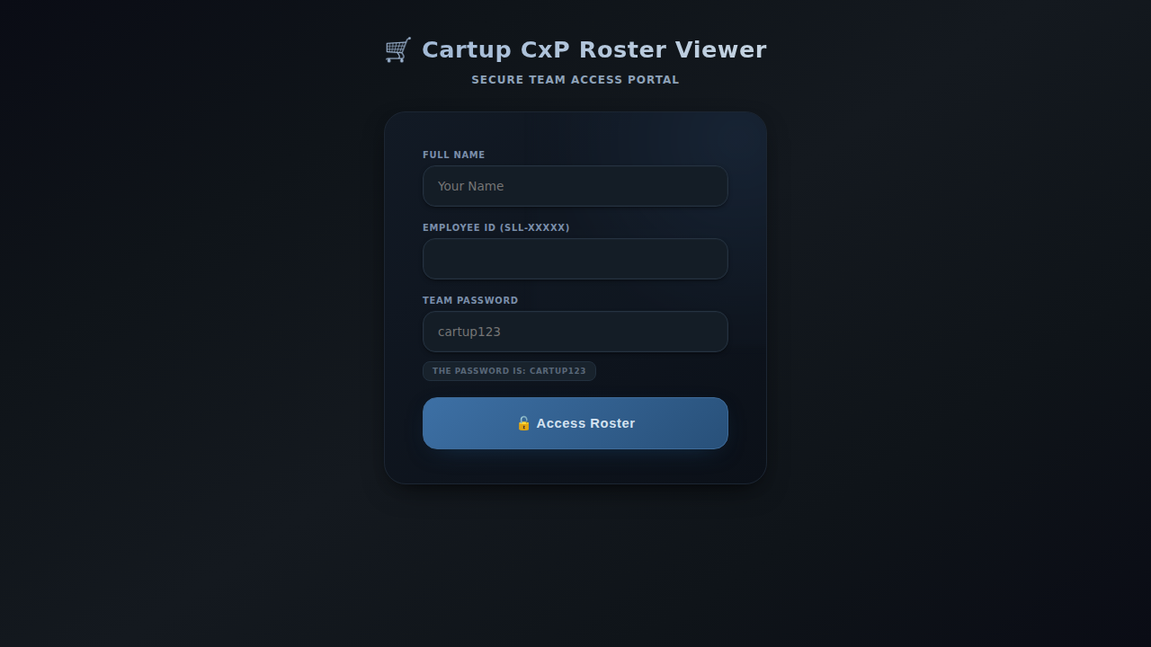

*Client Login Page*

**Note:** The Employee ID is case-sensitive. Make sure to enter it exactly as provided.

## 2.2 Dashboard Overview

Once logged in, you will see your personalized dashboard displaying:

* **Welcome Header:** Shows your name and Employee ID
* **Action Buttons:** Logout, Refresh, and Theme buttons
* **Current Shift Information:** Today and tomorrow shift details
* **Selected Date Shift:** Shows shift for any selected calendar date
* **Action Buttons Row:** Request Shift Change, Request Swap, and Shift View buttons
* **Employee Search:** Search bar to find and view other employees' schedules
* **Statistics Cards:** Upcoming Days, Planned Time Off, and Shift Changes

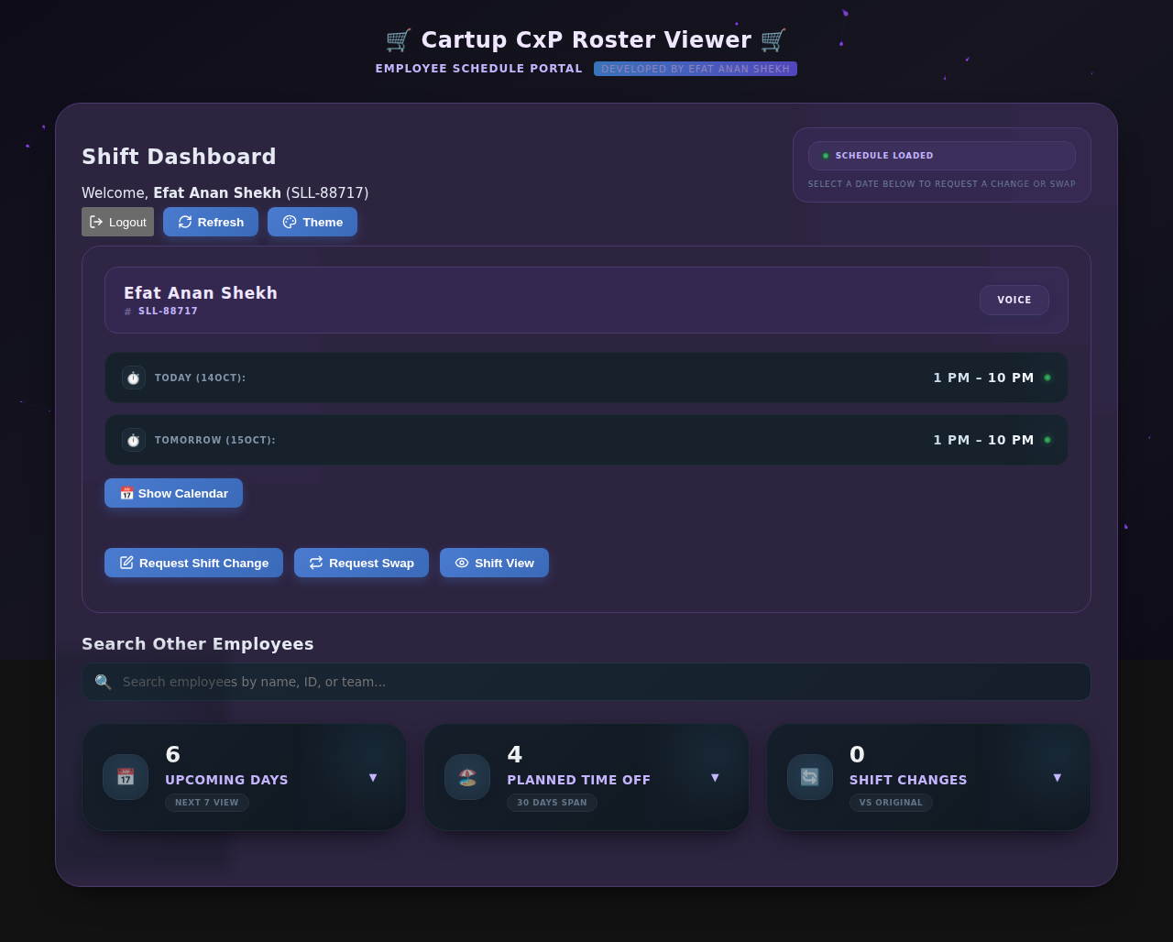

*Client Dashboard Overview*

## 2.3 Refresh Function

The Refresh button allows you to reload your schedule data to see the most up-to-date information including any recently approved shift changes.

How to use:

1. Locate the "🔄 Refresh" button in the top action bar
2. Click the button
3. The system will reload all schedule data
4. The button will show "Refreshing..." while loading
5. Once complete, all information will be updated

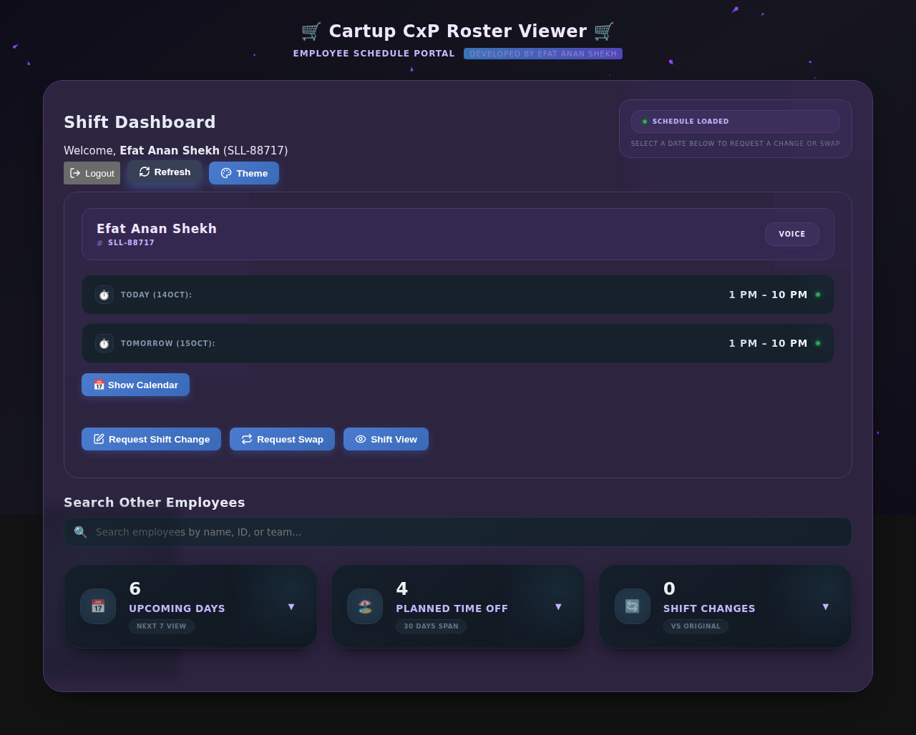

*Dashboard After Refresh*

## 2.4 Theme Customization

The system offers multiple color themes to personalize your experience. You can switch between different themes to find one that suits your preference.

Available Themes:

* 🌈 Bright Vibrant - Colorful and energetic
* 🌅 Bright Sunset - Warm and inviting
* 🌊 Medium Ocean - Cool blue tones
* 🌍 Medium Earth - Natural earth tones
* 🍃 Peaceful Sage - Calming green
* 💜 Peaceful Lavender - Soft purple
* 🌑 Dark Blue - Professional dark blue
* 🌃 Dark Midnight - Deep dark theme
* 🕳️ Dark Void - Maximum contrast black

How to change theme:

1. Click the "🎨 Theme" button in the top action bar
2. A dropdown menu will appear showing all available themes
3. Click on any theme to apply it immediately
4. The entire website will update with the new color scheme
5. Your selection is saved and will persist across sessions

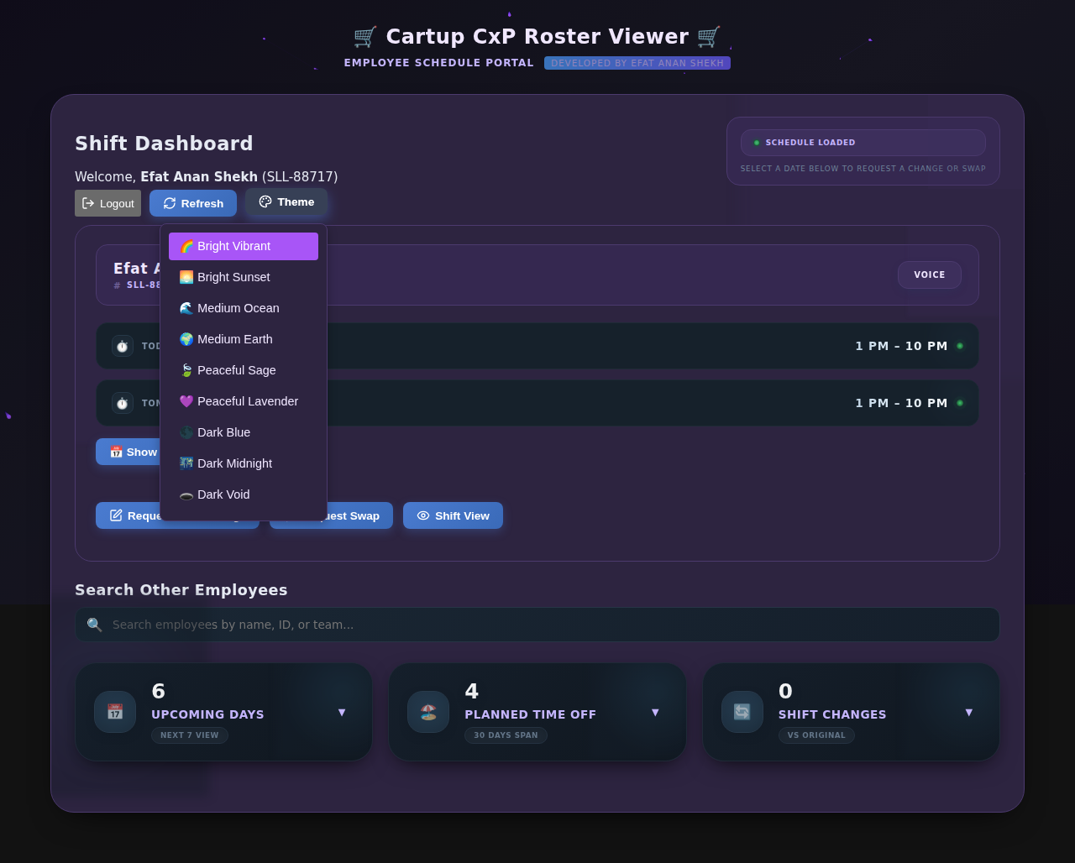

*Theme Menu Dropdown*

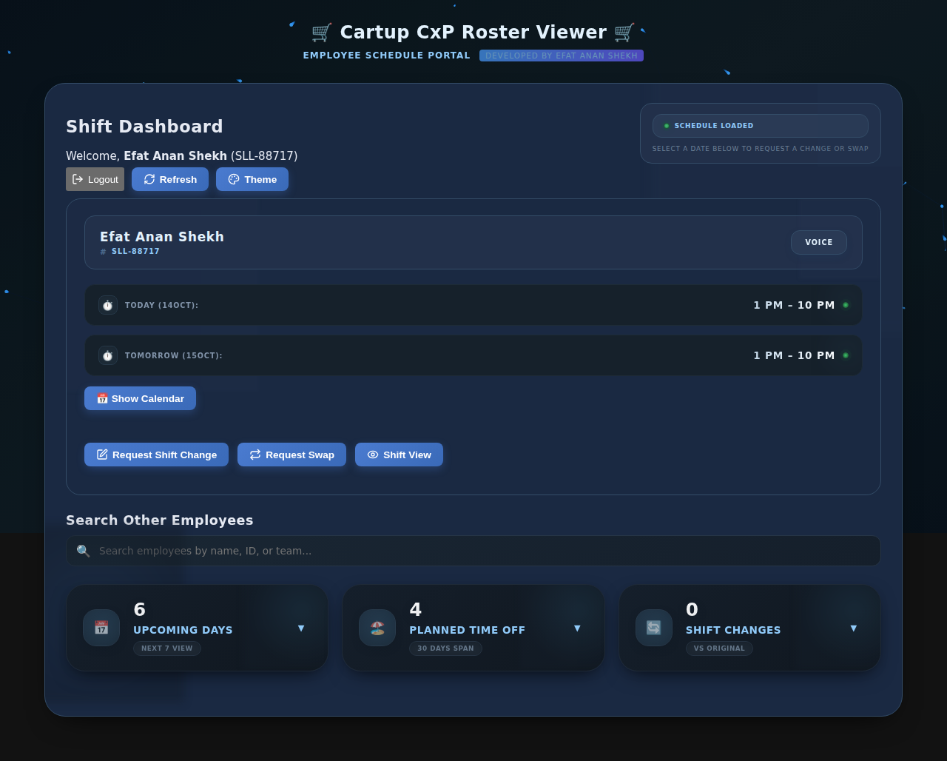

*Medium Ocean Theme Applied*

## 2.5 Calendar Feature

The calendar allows you to view your shift schedule for any date. When you select a date, the system displays your assigned shift for that day.

How to use the calendar:

1. Click the "📅 Show Calendar" button
2. The calendar will expand, showing the current month
3. Use the arrow buttons (← →) to navigate between months
4. Click on any date to view your shift for that day
5. The selected date and shift will appear above the calendar
6. Click "📅 Hide Calendar" to collapse the calendar

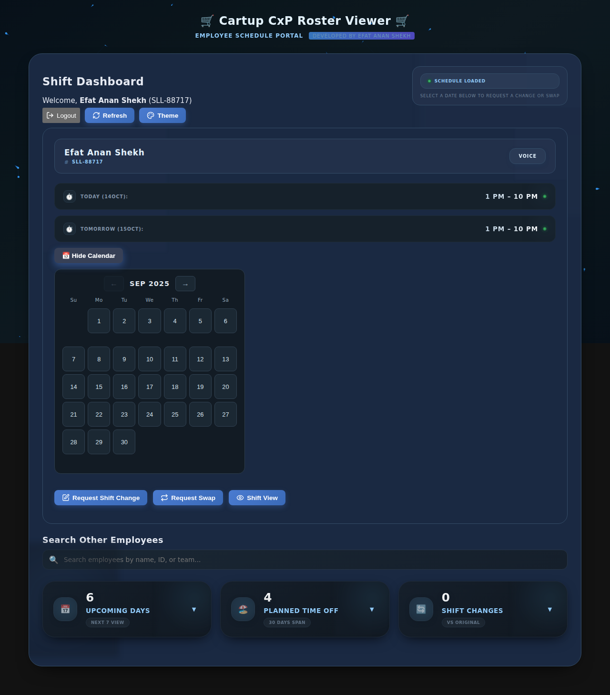

*Calendar Expanded (September)*

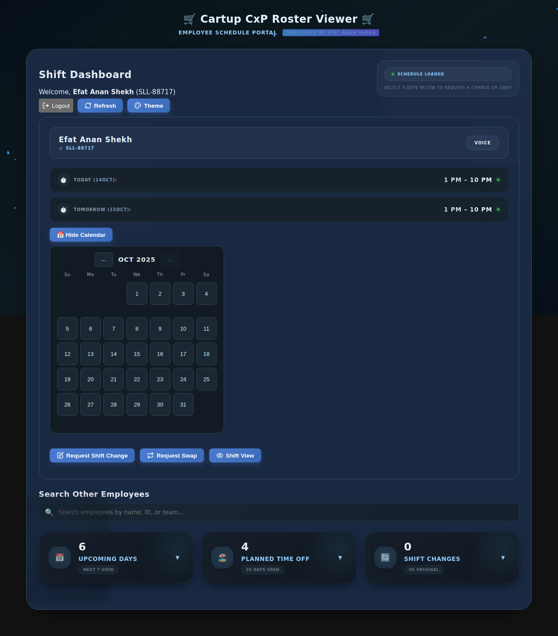

*Calendar Showing October*

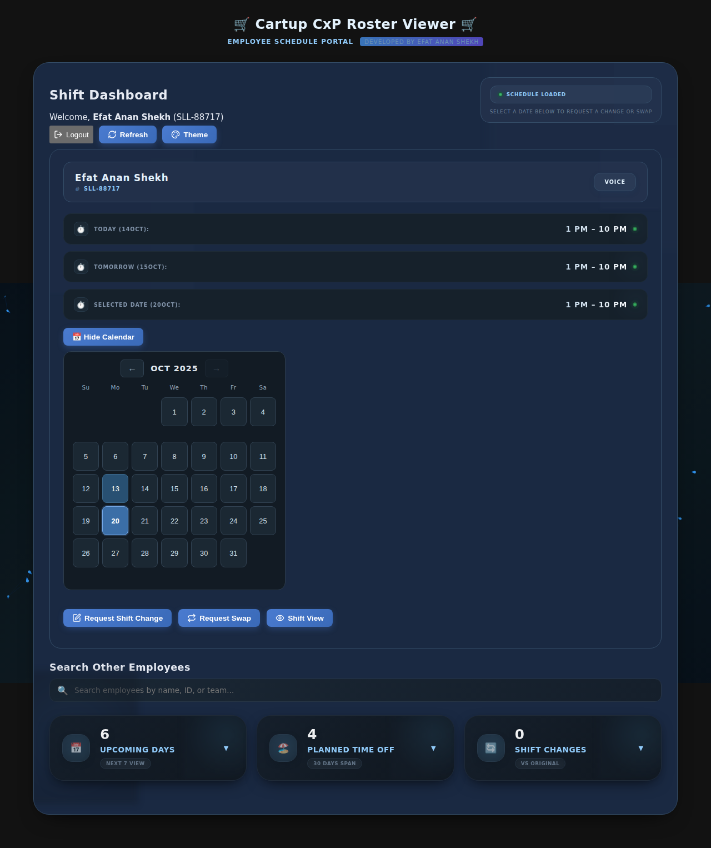

*Date Selected (October 20)*

## 2.6 Requesting Shift Changes

If you need to change your assigned shift for a specific date, you can submit a shift change request through the system. An administrator will review and approve or reject your request.

Step-by-step process:

1. Click the "✏️ Request Shift Change" button on the dashboard

2. The Shift Change Request modal will open

3. You will see your employee information and current team displayed

4. Select the date for which you want to change your shift using the mini calendar

5. Use the arrow buttons to navigate to the correct month if needed

6. Click on the desired date

7. Your current shift for that date will be displayed

8. Select your requested shift from the dropdown menu (M2, M3, M4, D1, D2, DO, SL, CL, EL, HL)

9. Enter a reason for your request in the text area

10. Click "Submit Request" to send your request to administrators

11. Click "Cancel" if you want to close the modal without submitting

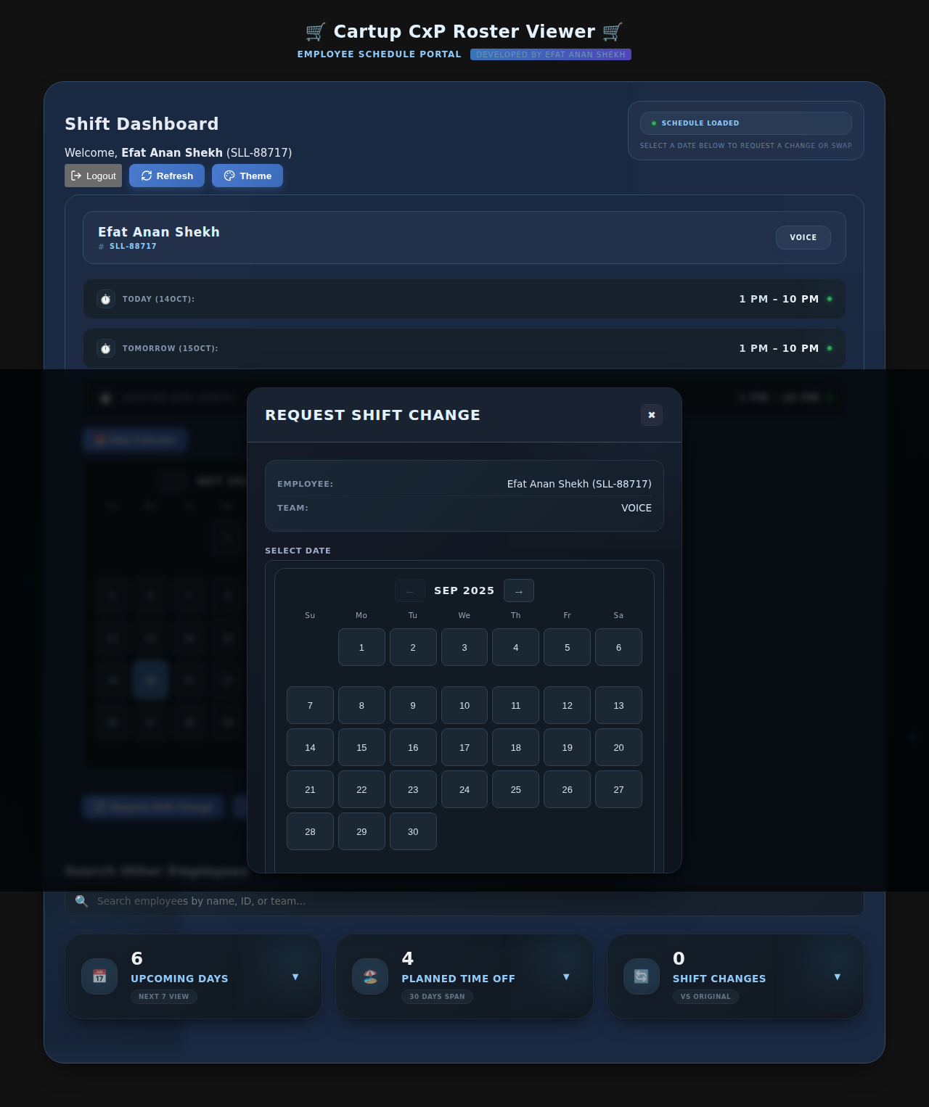

*Shift Change Request Modal*

**Important:** All shift change requests require administrator approval. You will be notified once your request is processed.

## 2.7 Requesting Shift Swaps

A shift swap allows you to exchange shifts with another team member. Both the requester and the target employee must be on the same team for a swap to be processed.

How to request a swap:

1. Click the "🔁 Request Swap" button on the dashboard

2. The Swap Request modal will open

3. Select the date for the swap using the calendar

4. Your current shift for that date will be displayed

5. In the "Swap With" field, start typing an employee name or ID

6. A list of team members will appear as you type

7. Select the employee you want to swap with

8. Enter a reason for the swap request

9. Click "Submit Swap Request"

10. The request will be sent to administrators for approval

**Note:** The system will only show employees from your team in the search suggestions. Cross-team swaps are not currently supported.

## 2.8 Shift View

The Shift View feature provides a comprehensive calendar-style view of team schedules, allowing you to see who is working on specific dates.

Using Shift View:

1. Click the "👁️ Shift View" button

2. The Shift View modal will open showing a calendar

3. Select a date from the calendar to view all shifts for that day

4. You can filter by team using the team dropdown

5. The view shows all employees and their assigned shifts

6. Use the arrow buttons to navigate between months

7. Click outside the modal or the close button to exit

**Tip:** Use this feature to coordinate with team members and plan coverage.

## 2.9 Employee Search

The employee search feature allows you to look up any employee in the system and view their schedule.

How to search for employees:

1. Locate the "Search Other Employees" section on the dashboard

2. Click in the search box

3. Start typing an employee name, ID, or team name

4. A dropdown list of matching employees will appear

5. Click on an employee from the list

6. Their schedule will replace yours on the dashboard temporarily

7. You can select dates from the calendar to see their shifts

8. Click the "← Back to My Schedule" button to return to your own schedule

**Use case:** This is useful for checking if a colleague is available on a specific day before requesting a swap.

## 2.10 Statistics Cards

The bottom of your dashboard displays three statistics cards that provide quick insights into your schedule:

* **📅 Upcoming Days:** Shows the number of working days in the next 7 days. Click to expand and see the list of dates you are scheduled to work.
* **🏖️ Planned Time Off:** Displays your time off days (DO, SL, CL, EL, HL) within the next 30 days. Click to expand and see all your scheduled off days with their types.
* **🔄 Shift Changes:** Shows the number of shifts that have been modified from the original Google Sheets roster. Click to expand and see details of what changed and when.

How to use:

1. Click on any card to expand it

2. The card will show detailed information

3. Click the "▲" arrow or anywhere outside to collapse

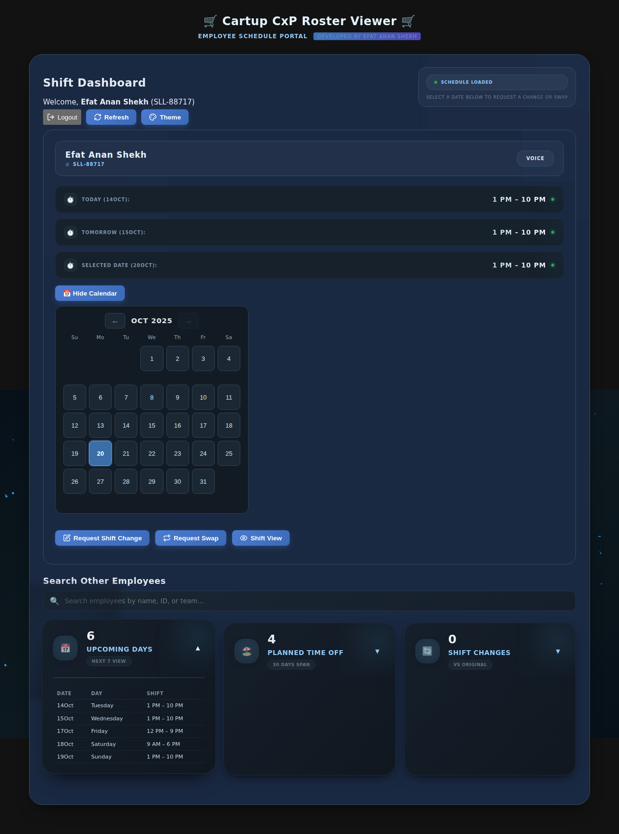

*Upcoming Days Stat Card Expanded*

**Tip:** Check these cards regularly to stay aware of your upcoming schedule and any changes.

# 3. Admin Panel User Guide

## 3.1 Admin Login

Administrators access a separate panel with advanced features for managing the entire roster system.

Default Admin Credentials:

|  |  |  |
| --- | --- | --- |
| Role | Username | Password |
| Super Admin | Username: developer | Password: devneversleeps |
| Admin | Username: istiaque | Password: cartup123 |
| Admin | Username: admin | Password: password123 |

Steps to login:

1. Navigate to http://localhost:3000/admin/login

2. Enter your admin username

3. Enter your password

4. Click "Login"

5. You will be redirected to the admin dashboard

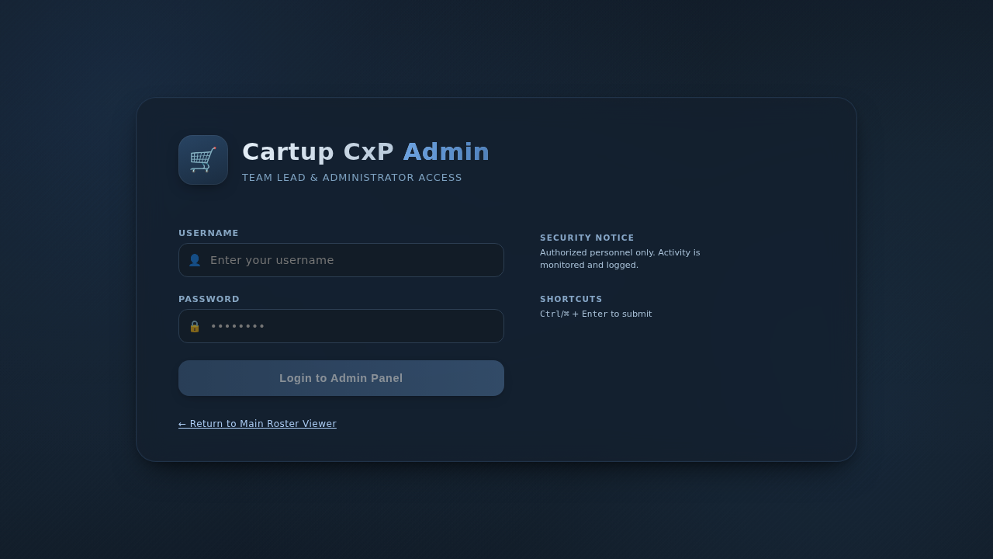

*Admin Login Page*

## 3.2 Dashboard Tab

The admin dashboard provides an overview of the entire roster system with key metrics and recent activity.

Dashboard Components:

* **👥 Total Employees This Month:** Shows the total number of employees in the system.
* **👷 Employees Working Today:** Displays count of employees with shifts today. Click to see the full list with their shifts.
* **Shift Change / Swap Requests Overview:** Statistics card showing pending, approved, and rejected requests. Click to expand for details.
* **Team Health Overview:** Shows team distribution and metrics. Expand to see detailed team information.
* **Activity Log:** Recent actions including approved requests, rejected requests, and shift modifications. Shows admin username who performed each action.

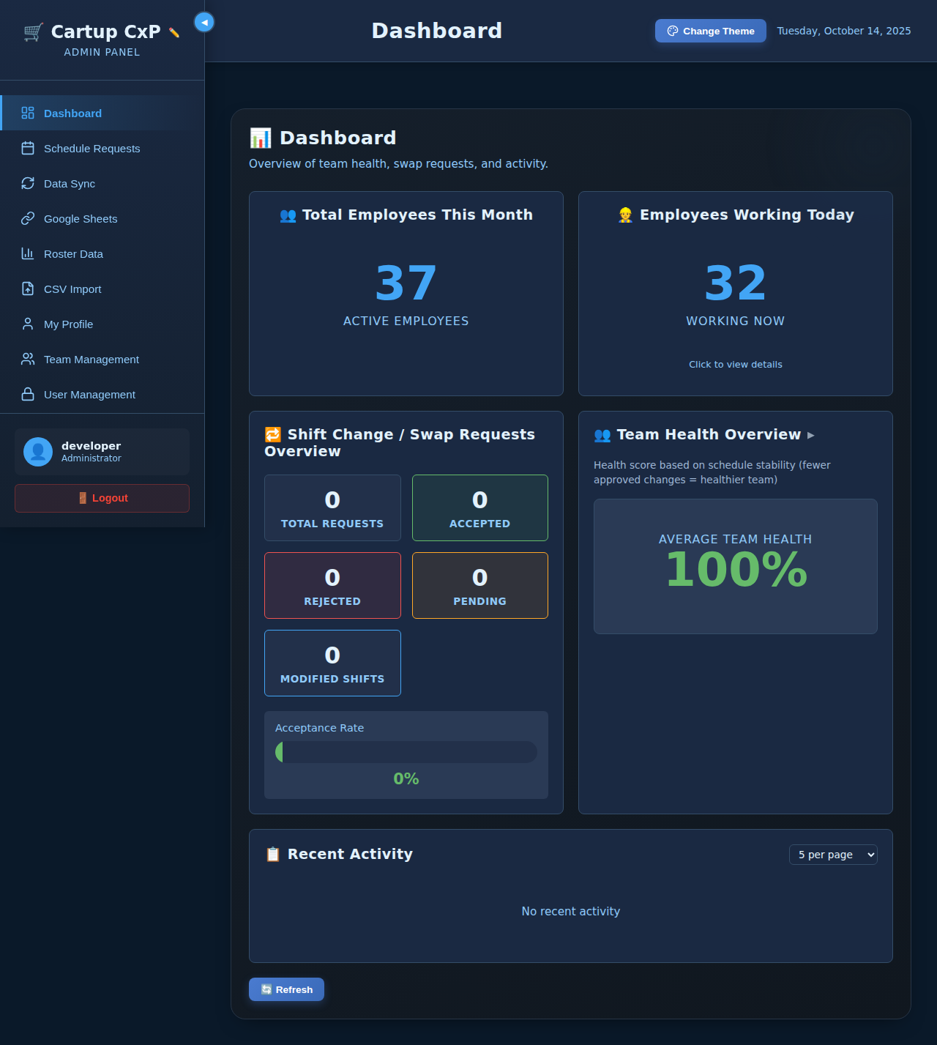

*Admin Dashboard Overview*

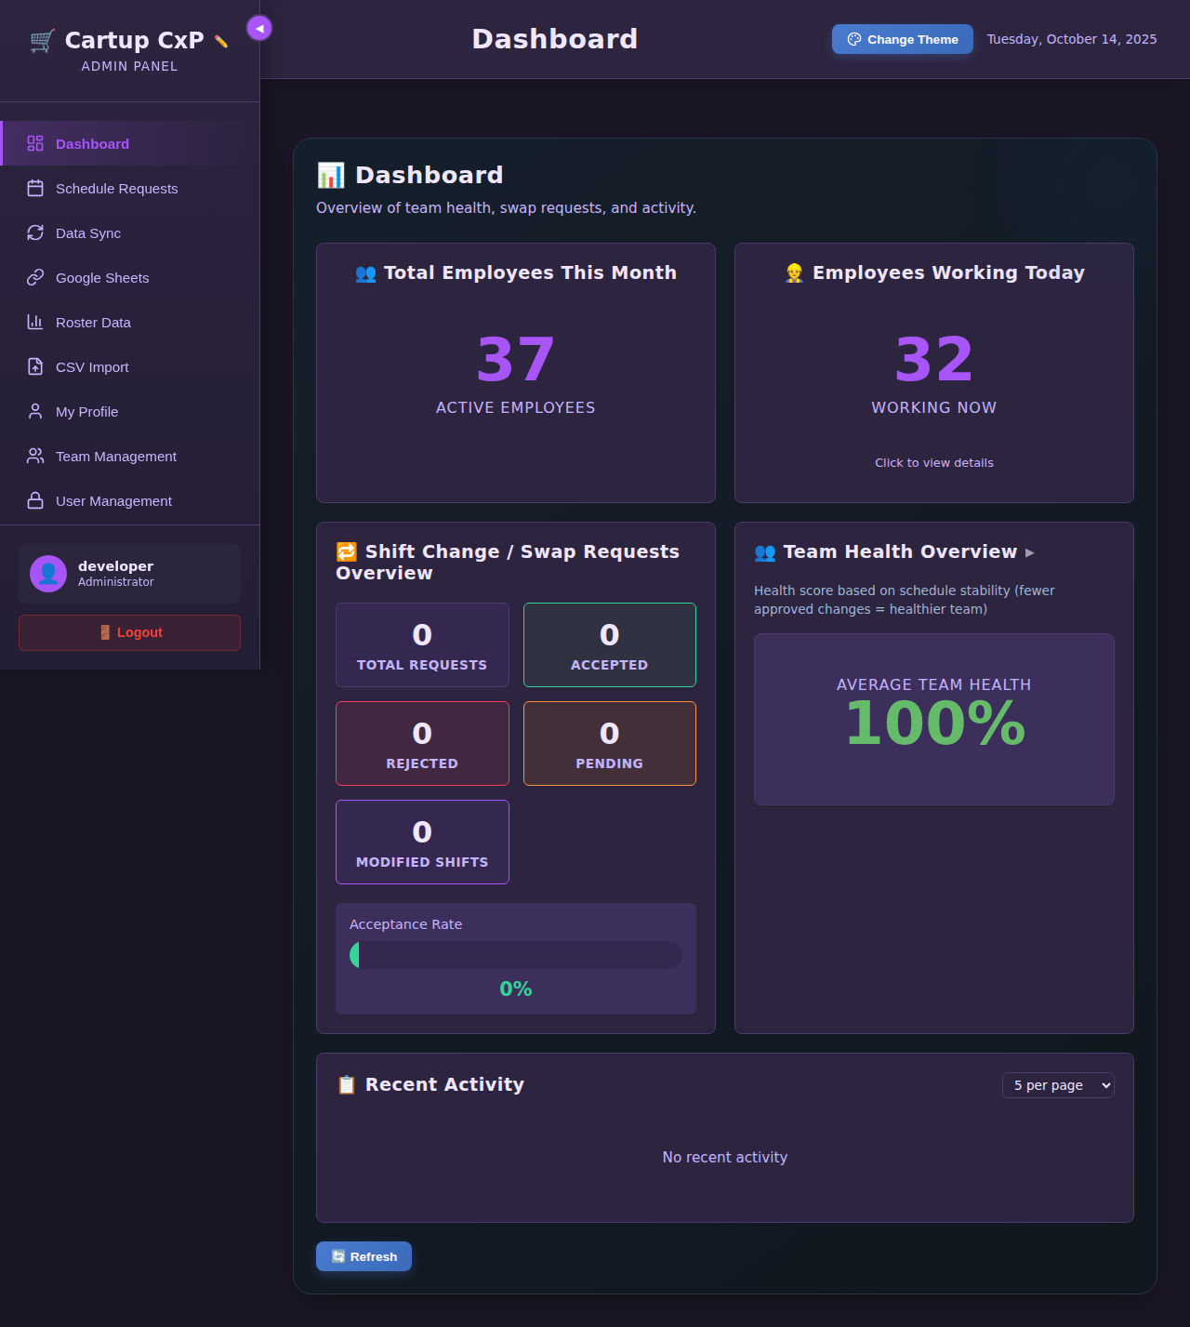

*Dashboard with All Stat Cards*

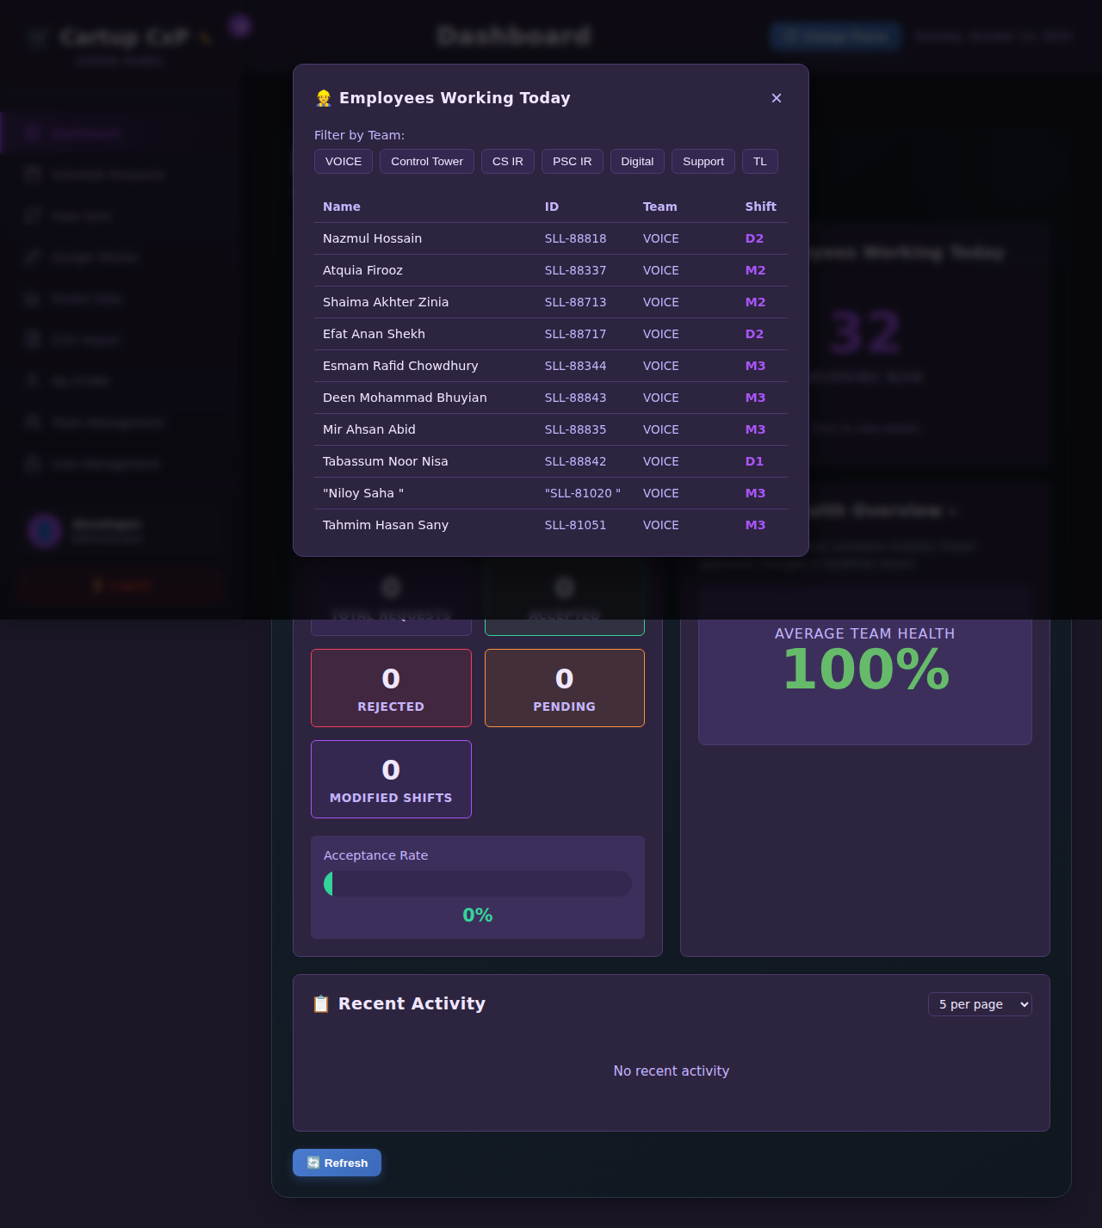

*Employees Working Today Modal*

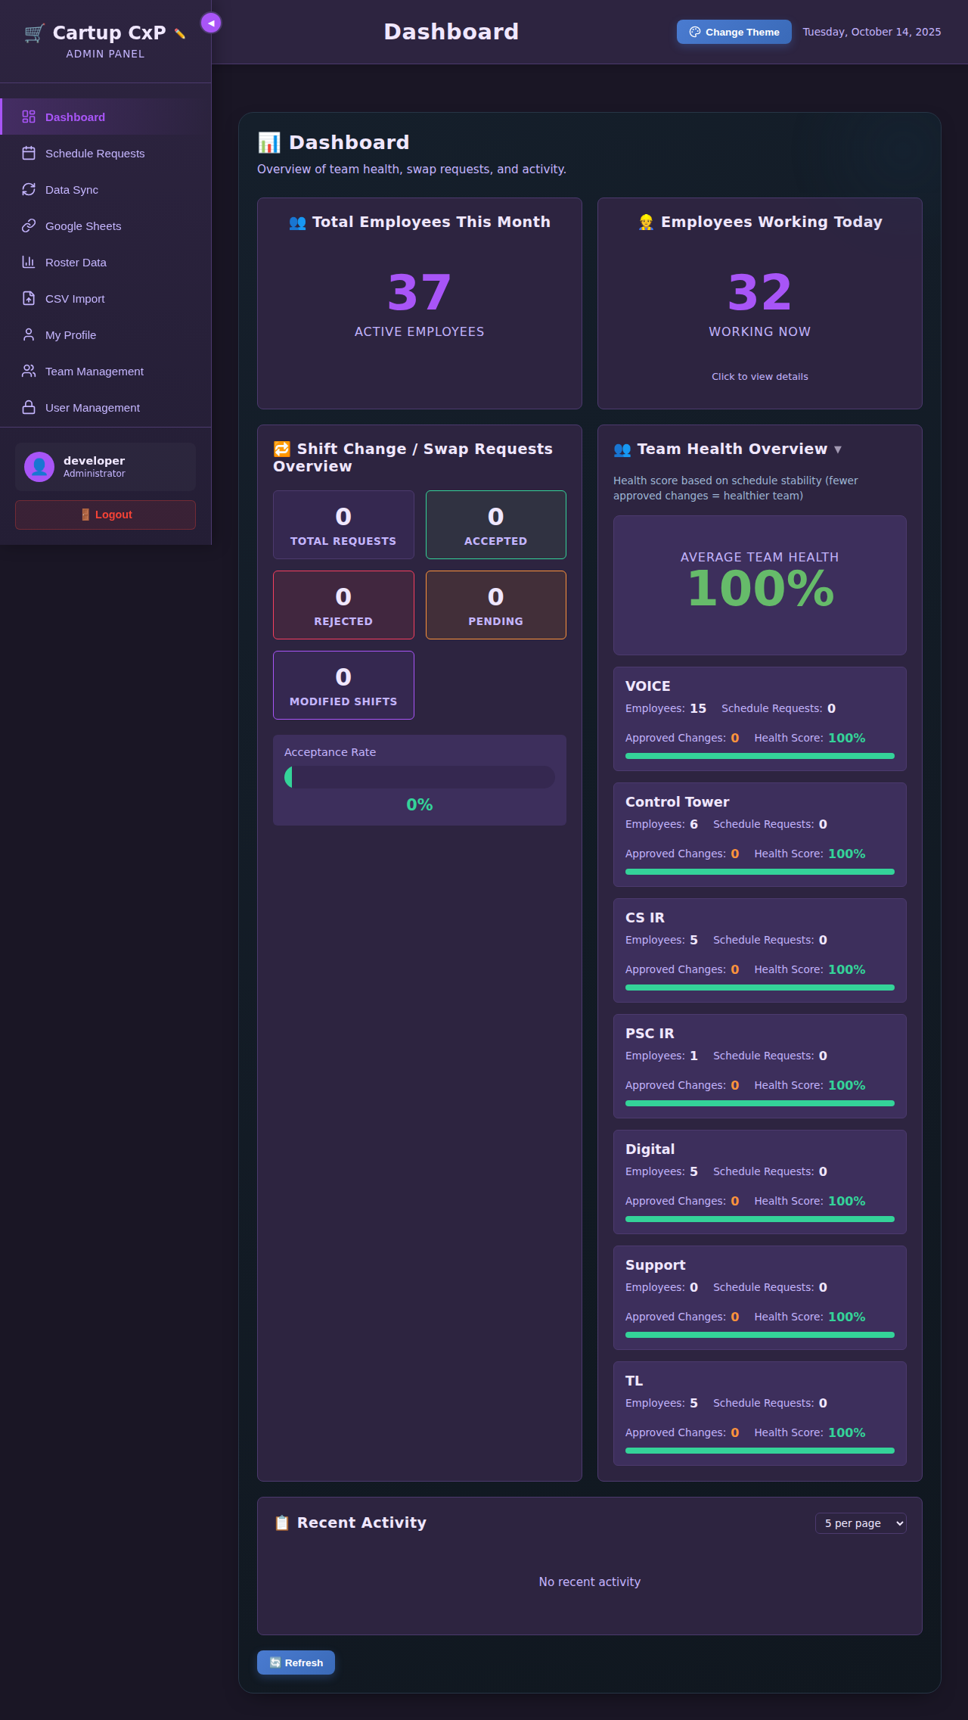

*Team Health Overview Expanded*

**How to use:** Click on any stat card to expand it and view detailed information. The activity log updates automatically as changes are made.

## 3.3 Schedule Requests Tab

This tab is where administrators review and process shift change and swap requests from employees.

Request Management:

1. Click on the "Schedule Requests" tab in the sidebar
2. You will see a list of all requests
3. Use the filter buttons to view: All, Pending, Approved, Rejected
4. For each request, you can see:
5. - Employee name and ID
6. - Request type (Shift Change or Swap)
7. - Requested date
8. - Current shift and requested shift
9. - Reason provided by employee
10. - Request submission date
11. To approve a request: Click the "✅ Approve" button
12. To reject a request: Click the "❌ Reject" button
13. You will be asked to confirm your action
14. Once processed, the request status updates immediately
15. The employee's schedule is updated for approved requests

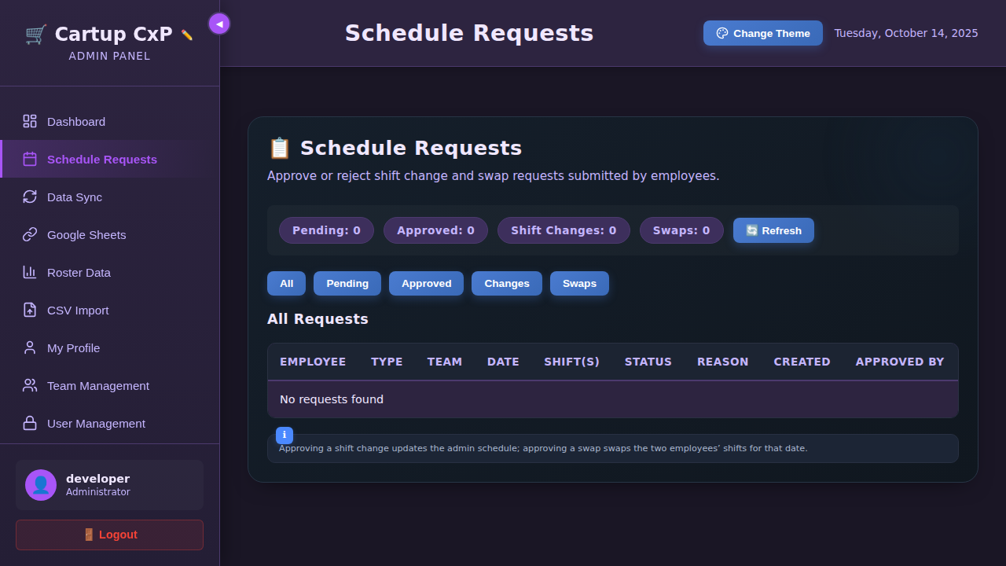

*Schedule Requests - All View*

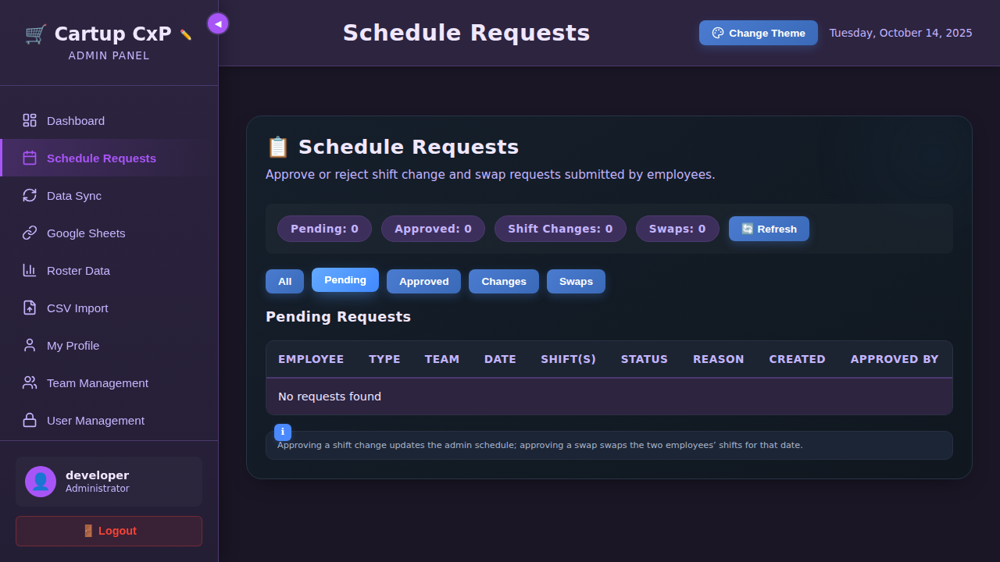

*Schedule Requests - Pending Filter*

**Important:** All actions are logged and cannot be undone. Approved shift changes immediately update the roster.

## 3.4 Data Sync Tab

The Data Sync tab allows you to synchronize roster data from Google Sheets and manage automatic synchronization settings.

Features:

* **Manual Sync Button:** Click to immediately fetch and update data from all configured Google Sheets links.
* **Auto-Sync Toggle:** Enable or disable automatic synchronization that runs at regular intervals.
* **Last Sync Time:** Shows when the last successful sync occurred.
* **Sync Statistics:** Displays number of employees and sheets synced.

How to perform a manual sync:

1. Navigate to the Data Sync tab

2. Click the "Sync Now" button

3. Wait for the sync to complete

4. A success message will appear

5. Check the sync statistics to verify

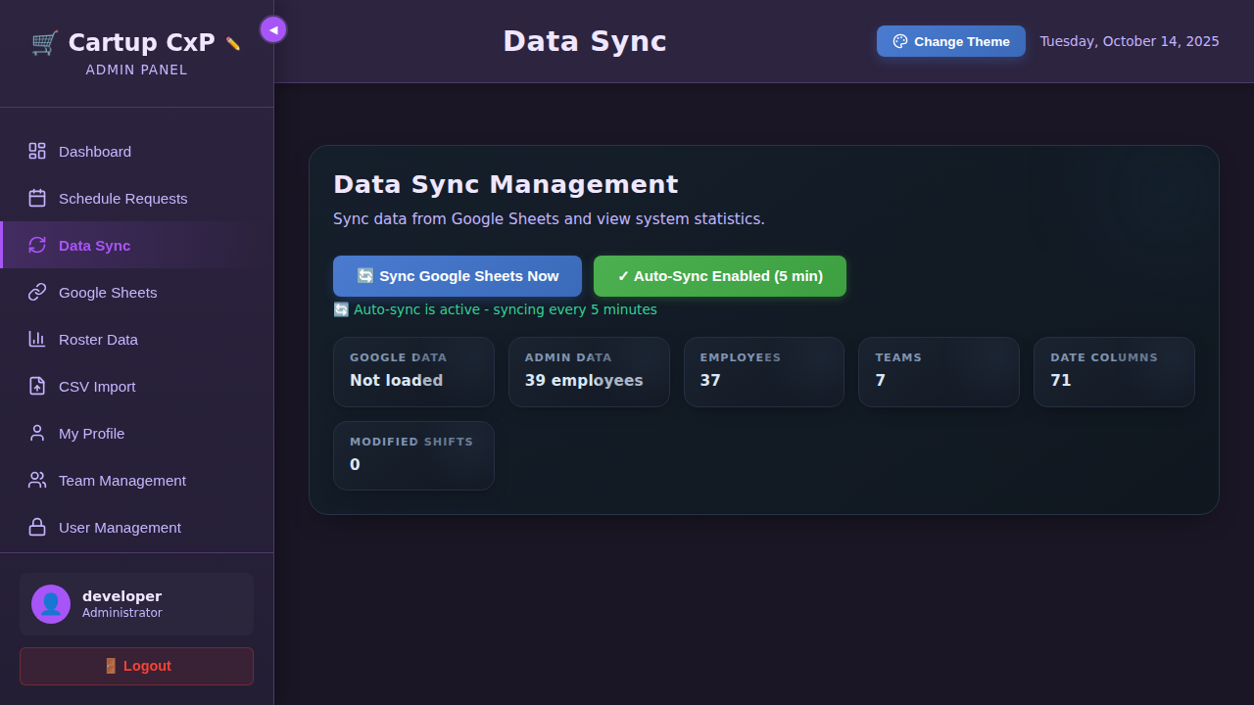

*Data Sync Tab*

## 3.5 Google Sheets Tab

Configure Google Sheets links for roster data import. The system supports multiple sheets to aggregate data from different teams or sources.

Managing Google Sheets Links:

To add a new link:

1. Click on the "Google Sheets" tab

2. Enter a descriptive name for the sheet (e.g., "Voice Team Roster")

3. Paste the published CSV link from your Google Sheet

4. Click "Add Link"

5. The link will be saved and used for future syncs

To delete a link:

1. Find the link in the list

2. Click the "Delete" button next to it

3. Confirm the deletion

**How to get a Google Sheets CSV link:**

1. Open your Google Sheet

2. Go to File → Share → Publish to web

3. Select "Comma-separated values (.csv)"

4. Click "Publish"

5. Copy the generated URL

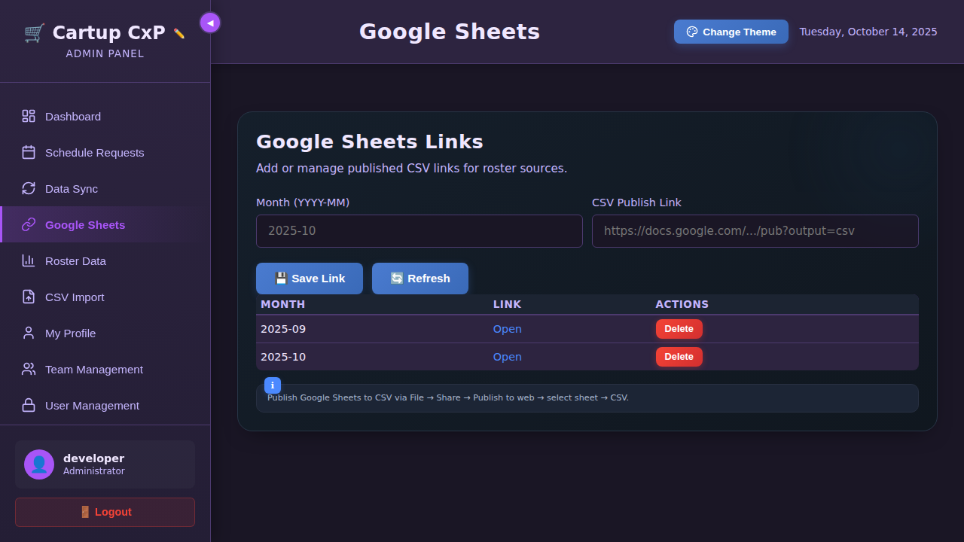

*Google Sheets Configuration Tab*

## 3.6 Roster Data Tab

The Roster Data tab provides an interactive interface to view and edit employee shifts directly.

Features:

* **Data Source Toggle:** Switch between viewing Google Sheets roster (original) and Admin modified roster.
* **Shift View Button:** Open a calendar-based view of the entire roster.
* **Reset to Google Button:** Reset all admin modifications and revert to the original Google Sheets data.
* **Date Selection:** Select any date to view and modify shifts for that day.
* **Employee List:** View all employees with their shifts for the selected date.
* **Shift Editing:** Click on any employee shift cell to change it.

How to modify a shift:

1. Go to the Roster Data tab

2. Select "Admin Data" to edit the modifiable roster

3. Click "Select Date to Modify Shifts"

4. Choose a date from the calendar

5. Find the employee whose shift you want to change

6. Click on their current shift code

7. A dropdown will appear with all available shift codes

8. Select the new shift

9. The change is saved automatically

10. The modification is tracked and logged

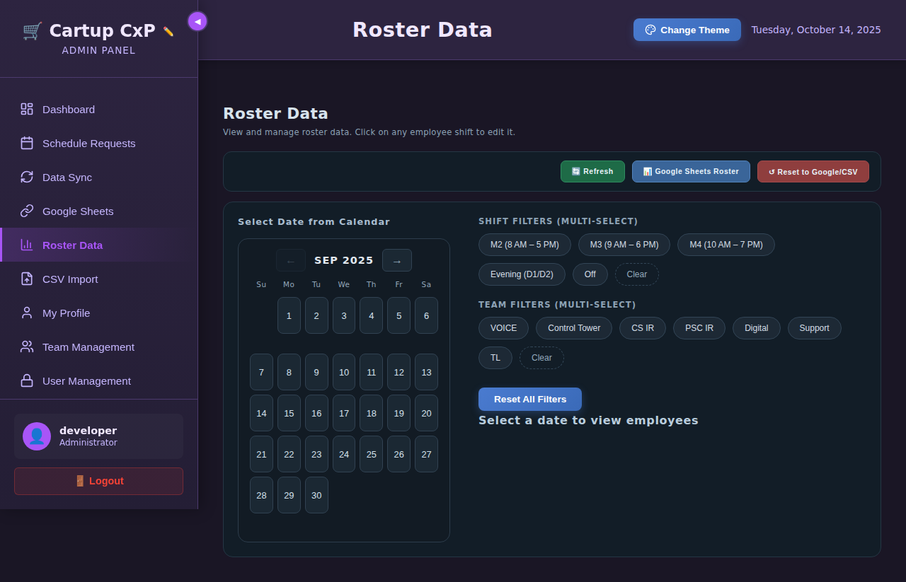

*Roster Data Tab with Calendar*

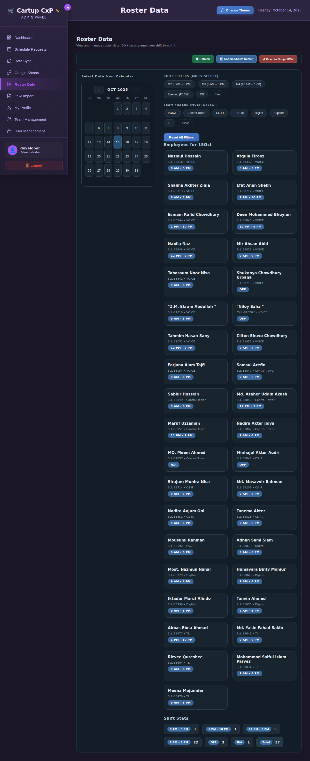

*Roster for October 15 with All Employees*

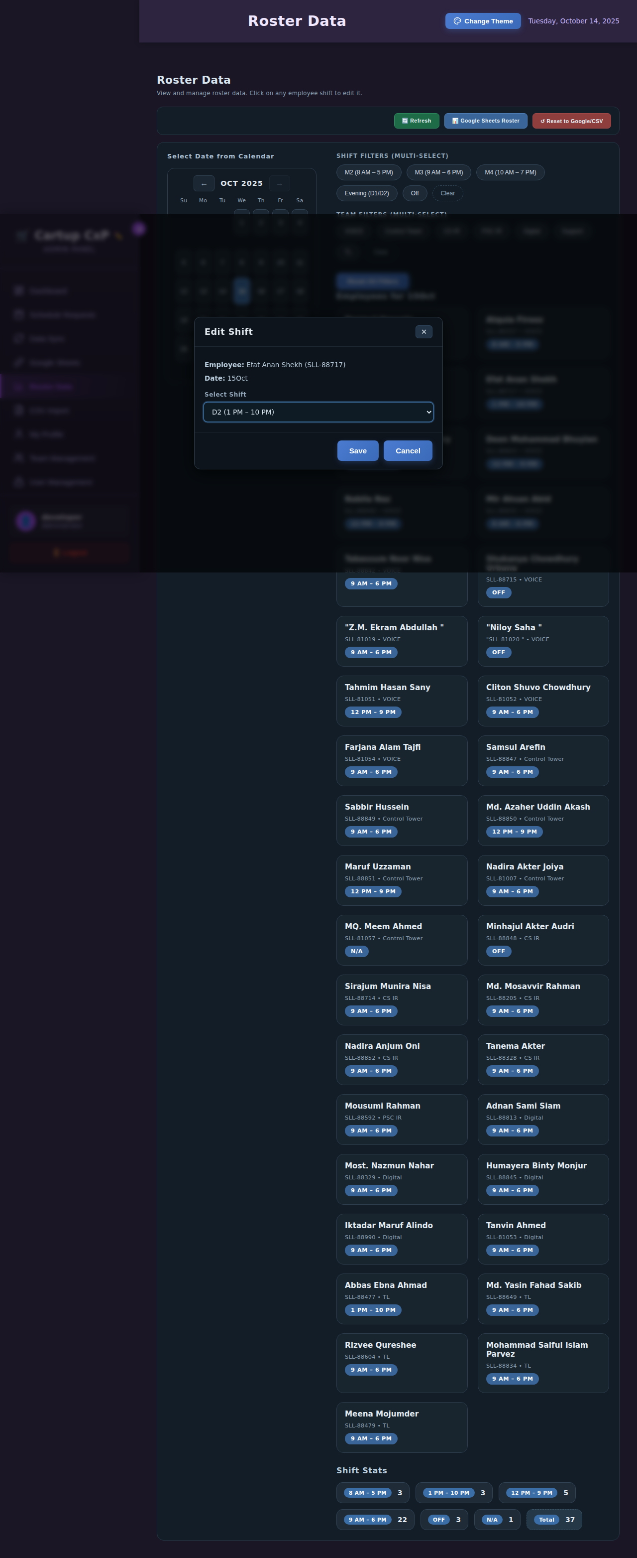

*Shift Edit Modal with Options*

## 3.7 CSV Import/Export Tab

Import and export roster data in CSV format for backup, bulk editing, or integration with external systems.

CSV Import:

1. Click on "CSV Import" tab

2. Click "Choose File" or drag and drop a CSV file

3. The file should follow the template format

4. Select the month this data is for

5. Click "Upload CSV"

6. The system will process and import the data

7. A success message confirms the import

CSV Export:

1. Go to the CSV Import tab

2. Select specific months to export or choose "Export All"

3. Click "📥 Export CSV"

4. The file will be generated and downloaded

5. Open the file in Excel or any spreadsheet application

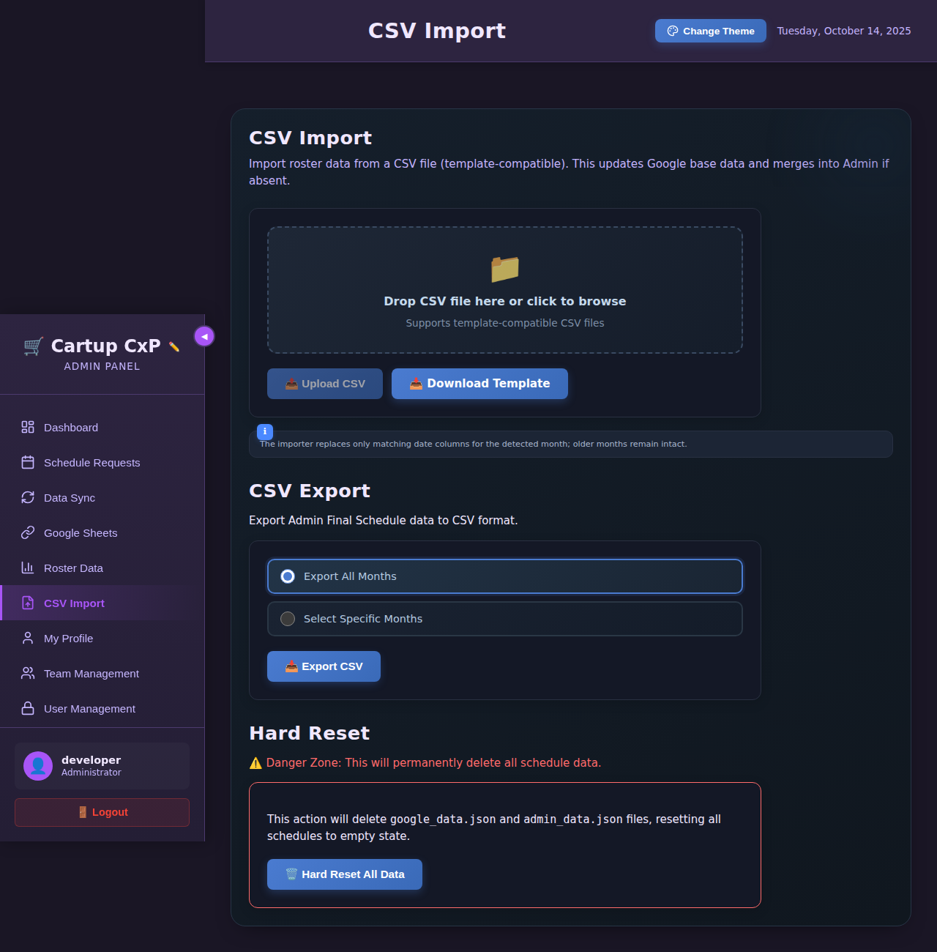

*CSV Import/Export Tab*

**CSV Format:** The CSV must have columns for Employee Name, Employee ID, Team, and date columns with shift codes.

## 3.8 My Profile Tab

Manage your admin account information and change your password.

Profile Information:

* Username (read-only)
* Role (read-only)
* Change password functionality

How to change your password:

1. Go to the "My Profile" tab

2. Enter your current password

3. Enter your new password

4. Re-enter the new password to confirm

5. Click "Change Password"

6. You will receive a confirmation message

7. Use your new password for future logins

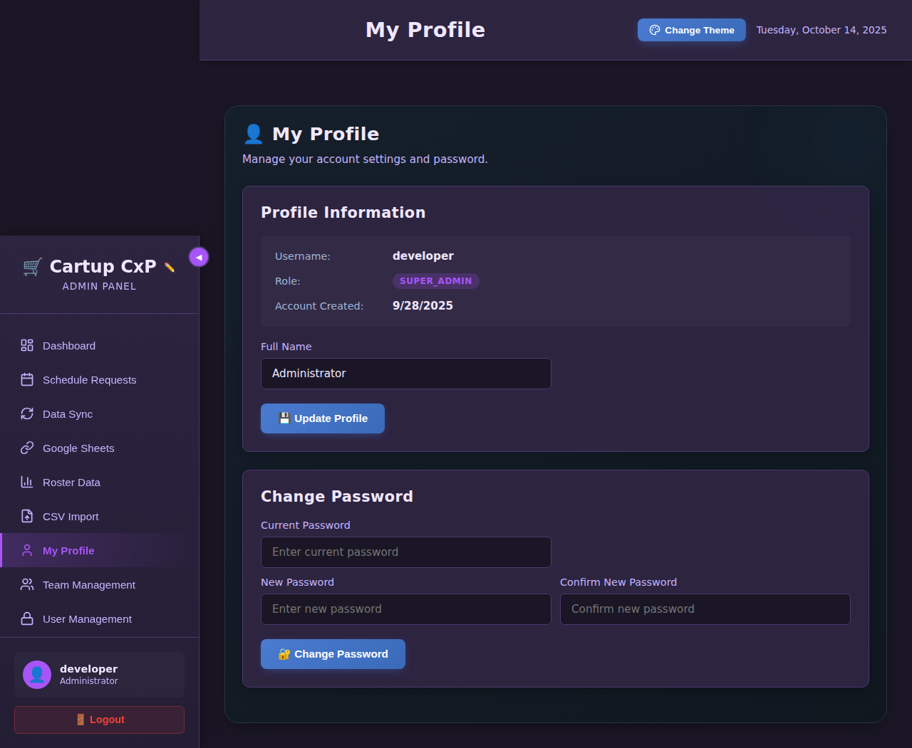

*My Profile Tab*

## 3.9 Team Management Tab

Manage teams and employees, including adding new employees, modifying information, and organizing team structures.

Team Management Features:

Adding a new team:

1. Click on "Team Management" tab

2. Click "Add New Team" button

3. Enter the team name

4. Optionally add a description

5. Click "Save"

6. The team will appear in the list

Adding a new employee:

1. Select the team from the dropdown

2. Click "Add Employee"

3. Fill in employee details:

4. - Full Name

5. - Employee ID (format: SLL-XXXXX)

6. - Team assignment

7. Click "Save Employee"

8. The employee will be added to the roster

Modifying employee information:

1. Find the employee in the list

2. Click "Edit" next to their name

3. Update the information

4. Click "Save Changes"

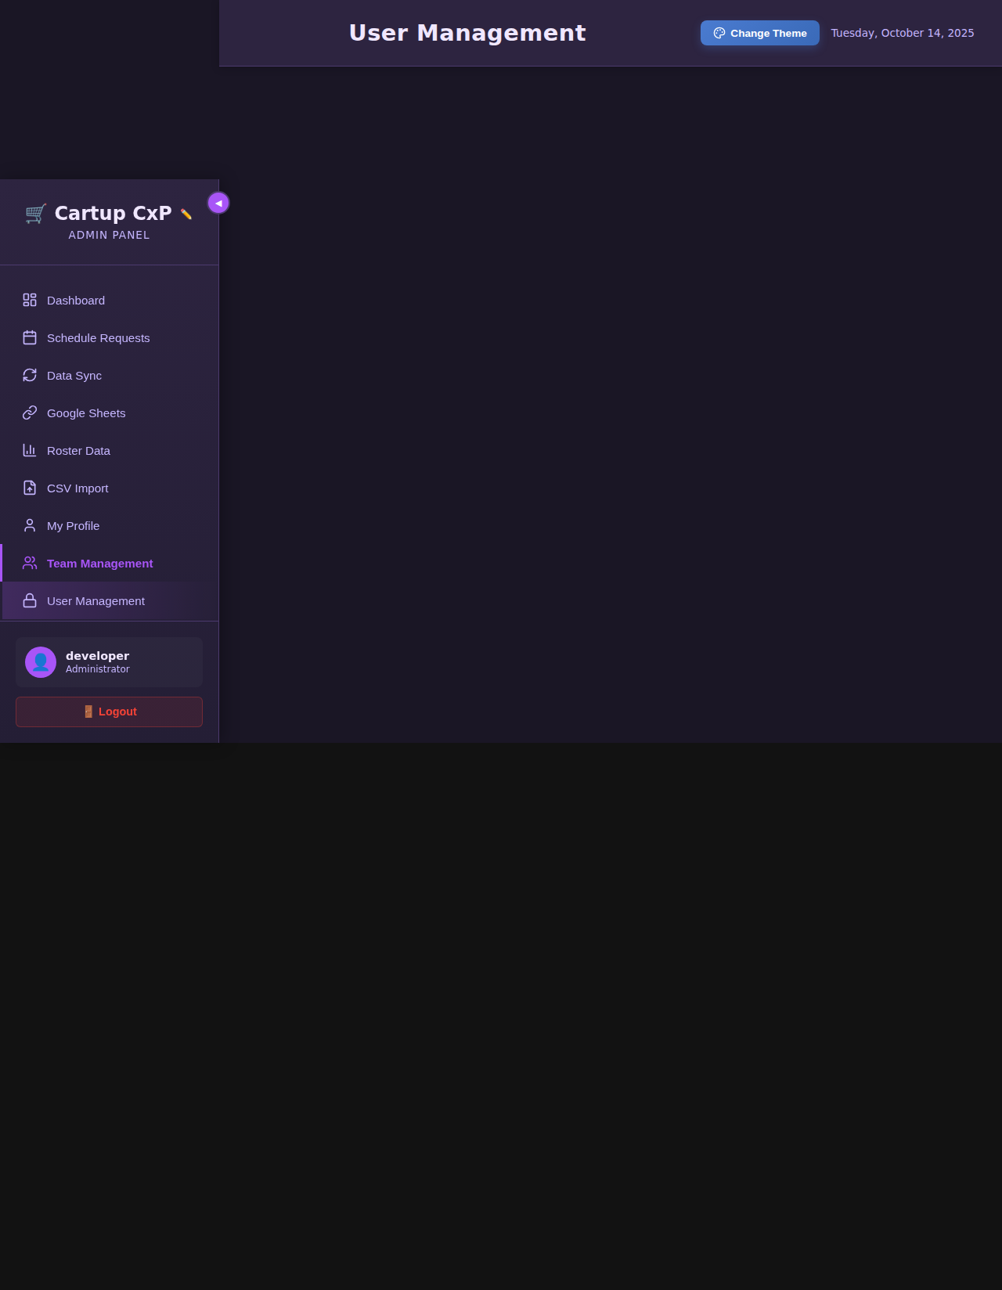

*Team Management Tab*

## 3.10 User Management Tab

Manage administrator accounts, including creating new users, updating roles, and deleting accounts. Note: This tab is only visible to Super Admins and Admins.

User Roles:

* **super_admin:** Full system access including user management
* **admin:** Can manage rosters and requests, view user management
* **team_leader:** Limited access to team-specific functions

Adding a new admin user:

1. Go to the "User Management" tab

2. Click "Add New User"

3. Fill in the form:

4. - Username (unique)

5. - Password

6. - Confirm Password

7. - Select Role

8. Click "Create User"

9. The user can now log in with these credentials

Deleting a user:

1. Find the user in the list

2. Click the "Delete" button

3. Confirm the deletion

4. The user account will be permanently removed

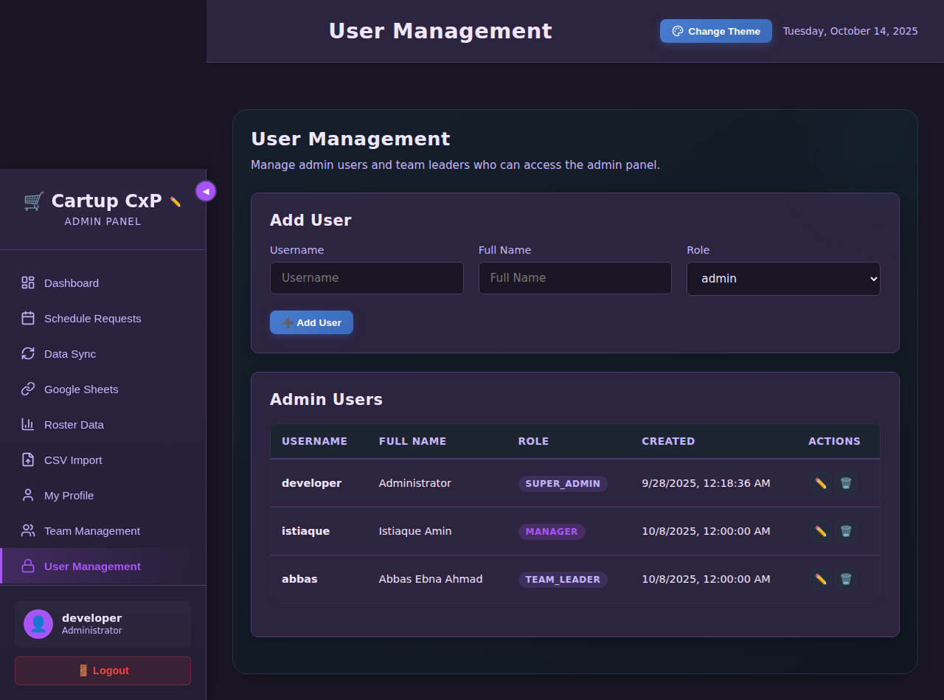

*User Management Tab*

# 4. API Documentation

This section documents all API endpoints available in the Cartup CxP Roster Management System. All APIs use JSON for request and response bodies.

## 4.1 Authentication APIs

POST /api/admin/login

Description: Admin login endpoint

Authentication: None required

Request Body: {"username": "string", "password": "string"}

Response: {"success": true, "user": {"username": "string", "role": "string"}}

POST /api/admin/logout

Description: Admin logout endpoint

Authentication: Admin cookie required

Request Body: None

Response: {"success": true}

## 4.2 Schedule APIs

GET /api/my-schedule/[employeeId]

Description: Get employee schedule

Parameters: employeeId - Employee ID (e.g., SLL-88717)

Response: {"employee": {...}, "headers": [...], "schedule": [...]}

GET /api/admin/get-display-data

Description: Get merged display roster data

Response: {"teams": {...}, "headers": [...], "allEmployees": [...]}

GET /api/admin/get-admin-data

Description: Get admin-modified roster data

Response: {"teams": {...}, "headers": [...], "allEmployees": [...]}

GET /api/admin/get-google-data

Description: Get original Google Sheets roster data

Response: {"teams": {...}, "headers": [...], "allEmployees": [...]}

## 4.3 Request APIs

POST /api/schedule-requests/submit-shift-change

Description: Submit a shift change request

Request Body:

{  
 "employee_id": "string",  
 "employee_name": "string",  
 "team": "string",  
 "date": "string",  
 "current_shift": "string",  
 "requested_shift": "string",  
 "reason": "string"  
}

Response:

{"success": true, "message": "Request submitted"}

POST /api/schedule-requests/submit-swap-request

Description: Submit a shift swap request

Request Body:

{  
 "requester_id": "string",  
 "requester_name": "string",  
 "swap_with_id": "string",  
 "swap_with_name": "string",  
 "team": "string",  
 "date": "string",  
 "reason": "string"  
}

Response:

{"success": true, "message": "Swap request submitted"}

GET /api/schedule-requests/get-all

Description: Get all schedule requests

Response:

[{"id": "string", "type": "string", "status": "string", ...}]

POST /api/schedule-requests/update-status

Description: Approve or reject a request (admin only)

Request Body:

{"id": "string", "status": "approved|rejected", "admin_username": "string"}

Response:

{"success": true}

## 4.4 Admin APIs

POST /api/admin/update-shift

Description: Update employee shift for a specific date

Request Body:

{  
 "employee_id": "string",  
 "date": "string",  
 "shift_code": "string",  
 "admin_username": "string"  
}

Response:

{"success": true}

POST /api/admin/upload-csv

Description: Upload roster CSV file

Request Body:

multipart/form-data with file and month

Response:

{"success": true, "message": "CSV imported"}

POST /api/admin/export-csv

Description: Export roster data as CSV

Request Body:

{"months": ["string"]}

Response:

CSV file download

POST /api/admin/save-team

Description: Create or update a team

Request Body:

{"name": "string", "description": "string"}

Response:

{"success": true}

POST /api/admin/save-employee

Description: Create or update an employee

Request Body:

{"id": "string", "name": "string", "team": "string"}

Response:

{"success": true}

## 4.5 Data Sync APIs

POST /api/admin/sync-google-sheets

Description: Manually trigger Google Sheets sync

Response:

{"success": true, "employees": number, "sheets": number}

POST /api/admin/set-auto-sync

Description: Enable or disable automatic sync

Request Body:

{"enabled": boolean}

Response:

{"success": true}

POST /api/admin/reset-to-google

Description: Reset admin data to Google Sheets data

Response:

{"success": true, "message": "Data reset"}

GET /api/admin/get-modified-shifts

Description: Get list of all modified shifts

Response:

[{"employee_id": "string", "date": "string", "old_shift": "string", "new_shift": "string", ...}]

# 5. Frequently Asked Questions (FAQ)

## 5.1 General Questions

**Q: What browsers are supported?**

A: The system works best on modern browsers including Chrome, Firefox, Safari, and Edge. We recommend using the latest version of Chrome for the best experience.

**Q: Is the system mobile-friendly?**

A: Yes! The system is fully responsive and works on mobile devices, tablets, and desktops. The interface adapts to your screen size.

**Q: How often is the data updated?**

A: If auto-sync is enabled, data is synchronized from Google Sheets every hour. You can also manually refresh at any time using the Refresh button.

**Q: Can I access the system from home?**

A: Yes, if your organization has made the system accessible externally. Contact your IT department for the correct URL and VPN requirements if needed.

## 5.2 Client Panel Questions

**Q: Why can't I log in?**

A: Make sure you are entering your Employee ID correctly (format: SLL-XXXXX). The ID is case-sensitive. Also verify that the password is "cartup123". If issues persist, contact your administrator.

**Q: How do I know if my request was approved?**

A: Check the "Shift Changes" stat card on your dashboard. Approved changes will be reflected there. You can also check your schedule - approved changes will show the new shift.

**Q: Can I cancel a request after submitting?**

A: Currently, you cannot cancel a request yourself. Contact your administrator if you need to cancel a pending request.

**Q: Why can't I request a swap with someone?**

A: You can only swap shifts with team members from your own team. The system will only show employees from your team in the swap request search.

**Q: What do the shift codes mean?**

A: M2 (8 AM-5 PM), M3 (9 AM-6 PM), M4 (10 AM-7 PM), D1 (12 PM-9 PM), D2 (1 PM-10 PM), DO (Day Off), SL (Sick Leave), CL (Casual Leave), EL (Emergency Leave), HL (Holiday Leave).

## 5.3 Admin Panel Questions

**Q: How do I add a new employee to the system?**

A: Go to Team Management tab, select the team, click "Add Employee", fill in the details (Name, ID, Team), and save. The employee will appear in the roster immediately.

**Q: What happens when I approve a shift change request?**

A: The employee's shift is immediately updated in the admin roster. The change is logged in the modification history and appears in the activity feed.

**Q: Can I undo a shift modification?**

A: Yes, you can manually change the shift back to the original value, or use the "Reset to Google" button to reset all modifications at once (warning: this resets ALL changes).

**Q: How do I bulk import employee schedules?**

A: Use the CSV Import tab. Download the template, fill it with your data following the format, then upload it. Select the correct month before uploading.

**Q: What's the difference between Google Data and Admin Data?**

A: Google Data is the original roster from Google Sheets (read-only). Admin Data includes all modifications made by administrators. The system displays a merge of both.

## 5.4 Troubleshooting

**Issue: Page not loading or showing errors**

Solution: Try refreshing the page (F5). Clear your browser cache. Check your internet connection. If the issue persists, contact IT support.

**Issue: Data not updating after sync**

Solution: Click the manual refresh button. Check if the Google Sheets links are correctly configured. Verify that the Google Sheet is published correctly as CSV.

**Issue: Cannot upload CSV file**

Solution: Ensure the file is in CSV format (.csv extension). Check that the file follows the template format. File size should not exceed 5MB. Try a different browser.

**Issue: Theme not applying correctly**

Solution: Clear your browser cache. Try selecting the theme again. Check if JavaScript is enabled in your browser settings.

**Issue: Forgot admin password**

Solution: Contact a Super Admin to reset your password through the User Management tab. Super Admins can reset passwords for other users.

# 6. Appendices

## 6.1 Shift Codes Reference

Complete list of all shift codes used in the system:

|  |  |  |
| --- | --- | --- |
| Code | Time/Type | Description |
| M2 | 8 AM – 5 PM | Morning Shift 2 |
| M3 | 9 AM – 6 PM | Morning Shift 3 |
| M4 | 10 AM – 7 PM | Morning Shift 4 |
| D1 | 12 PM – 9 PM | Day Shift 1 |
| D2 | 1 PM – 10 PM | Day Shift 2 |
| DO | Day Off | Scheduled day off |
| SL | Sick Leave | Medical leave |
| CL | Casual Leave | Personal leave |
| EL | Emergency Leave | Urgent/emergency leave |
| HL | Holiday Leave | Public holiday or scheduled holiday |

## 6.2 Quick Reference Guide

Client Panel Quick Actions:

|  |  |
| --- | --- |
| Action | How To |
| View Schedule | Login → Dashboard shows today/tomorrow |
| Change Theme | Click Theme button → Select from dropdown |
| Request Shift Change | Click Request Shift Change → Select date → Choose shift → Submit |
| Request Swap | Click Request Swap → Select date → Choose employee → Submit |
| View Team Schedule | Click Shift View → Select date and team |
| Search Employee | Type in search box → Click employee |

Admin Panel Quick Actions:

|  |  |
| --- | --- |
| Action | How To |
| Approve Request | Schedule Requests tab → Find request → Click Approve |
| Modify Shift | Roster Data tab → Select date → Click shift → Choose new shift |
| Sync Data | Data Sync tab → Click Sync Now |
| Add Employee | Team Management tab → Add Employee → Fill form → Save |
| Export CSV | CSV Import tab → Select months → Click Export |
| Add Admin User | User Management tab → Add New User → Fill details → Create |

# Support & Contact

For technical support, questions, or issues with the Cartup CxP Roster Management System, please contact:

IT Support Team

Email: support@cartup.com

Phone: +1-XXX-XXX-XXXX

Hours: Monday - Friday, 9 AM - 5 PM

System Administrator

Email: admin@cartup.com

---

Document Version: 1.0

Last Updated: October 2025

© 2025 Cartup CxP. All rights reserved.